**SECTION A (60 Marks)**

Answer only **three** questions from this section.

1. Define the following terms: (@01 mark)
2. Azeotropic mixture.
3. Steam distillation.
4. At 101.325kPa, the boiling point of water is 100ᵒC while that of ethanol is 78.5ᵒC. A 95.6% ethanol mixture of two liquids has a constant boiling point of 78.2ᵒC, at the same pressure.
5. Sketch a labelled boiling point-composition graph of water-ethanol mixture, at 101.325kPa. (03 marks)
6. Explain how water-ethanol mixture deviates from Raoult’s law. (03 marks)
7. Using the graph in b (i) above, describe what happens when a mixture containing 40% ethanol is fractionally distilled. (03 marks)
8. Chlorobenzene and water are immiscible. The table below gives the vapour pressure of both chlorobenzene and water, at various temperature.

|  |  |  |  |  |  |
| --- | --- | --- | --- | --- | --- |
| Temperature [ᵒC] | 70 | 80 | 90 | 100 | 110 |
| V.P of C6H5Cl [kN/m2] | 10 | 16 | 22 | 34 | 48 |
| V.P of H2O [kN/m2] | 28 | 44 | 68 | 100 | 142 |

1. Using the same axes, plot a graph of vapour pressure against temperature for chlorobenzene, water and mixture of water and chlorobenzene. (05 marks)
2. From the graph, determine the boiling point of the mixture at standard atmospheric pressure. (01 mark)
3. Calculate the percentage of chlorobenzene in the distillate when a mixture of chlorobenzene, and water distilled at standard atmospheric pressure. (03 marks)
4. When 2.25g of an organic compound, P was completely burnt in oxygen, 1.68dm3 of carbon dioxide gas and 1.35g water were formed at S.T.P. Calculate the empirical formula of compound, P. (03½ marks)
5. When 0.102g of compound, P was vapourized at a temperature of 273ᵒC and a pressure of 93.5kPa it occupied a volume of 55.0cm3. Determine the molecular formula of compound, P. (01½ marks)
6. When compound, P was treated with sodium carbonate, there was effervescence of a colourless gas. Write the structural formulae of the possible isomers of compound, P. (01 mark)
7. Compound, P formed yellow precipitate when treated with iodine solution and sodium hydroxide solution.
8. Identify compound, P. (0½ mark)
9. Write equation for the reaction leading to the formation of yellow precipitate. (01 mark)
10. Write and suggest a mechanism for the reaction between compound, P and:
11. Excess concentrated sulphuric acid at 170ᵒC. (04 marks)
12. Methanol in the presence of few drops of concentrated sulphuric acid. (04½ marks)
13. Using equation only, show how compound, P. (@02 marks)
14. Can be converted to ethanoic acid.
15. Can be synthesized from ethanol.
16. The pH value of 0.1M methanoic acid is 2.39.Calculate acid dissociation constant, Ka of the acid. (03 marks)
17. Comment on the way the value you have calculated in a (i) above compares with that of propanoic acid. (01 mark)
18. Draw a sketch titration-curve for the titration of ammonia with dilute hydrochloric acid. (01½ marks)
19. Explain the shape of the curve in b (i) above. (05½ marks)
20. Calculate pH of the solution when ammonia is half-way neutralized. (01½ marks)

[Base dissociation constant of ammonia = 1.8 x 10-5 mol/dm3]

1. 1.07g of ammonium chloride is dissolved in 1dm3 of 0.1M ammonia solution.
2. Calculate pH of the resulting solution. State any assumptions made. (05 marks)
3. Explain how the pH of the solution in c (i) will be affected when 1cm3 of 0.1M sodium hydroxide solution is added to the solution. (02½ marks)
4. Describe briefly the laboratory preparation of hydrogen chloride gas. (02 marks)
5. Describe how fluorine and chlorine each react with:
6. Water. (04 marks)
7. Sodium hydroxide solution. (07 marks)
8. Explain each of the following observations. (@03½ marks)
9. The atomization energy of fluorine is lower than that of chlorine.
10. Aluminium fluoride is ionic whereas aluminium chloride is covalent.

**SECTION B (40 Marks)**

Answer only **two** questions from this section.

1. Write equation and in each case suggest an accepted mechanism for the reaction between the following:
2. Benzene and fuming sulphuric acid. (03½ marks)
3. Propanoylchloride and aminoethane. (03½ marks)
4. Cyclohexanone and semicarbazide [H2NCONHNH2] in acidic medium. (04½ marks)
5. Using equations only show how the following conversions can be effected.
6. Propanoic acid from 1-bromopropane. (03 marks)
7. Phenylmethanal from benzene. (03 marks)
8. Iodobenzene from aminobenzene. (02½ marks)
9. Define the following terms: (@01 mark)
10. Standard enthalpy of solution.
11. Standard enthalpy of formation.
12. Given the data below:

Use the information above to determine the standard enthalpy of formation of rubidium sulphate. (04 marks)

1. Describe an experiment to determine the standard of solution of rubidium sulphate. (06 marks)
2. Calculate the lattice energy of rubidium sulphate, given that its enthalpy of solution is +24.3kJ/mol and the enthalpies of hydration of rubidium and sulphate ions are -301 & -560kJ/mol respectively. (04 marks)
3. Calculate the standard enthalpy of formation of ethanol, given that the enthalpies of combustion of ethanol, carbon & hydrogen are -1,371, -394 & -285.8kJ/mol respectively. (04 marks)
4. Write the: (@01 mark)
5. Electronic configuration of copper.
6. The formula and name of one ore of copper.
7. Describe how pure copper can be extracted frin the ore you have named in a (ii). (11 marks)
8. Discuss the reaction the copper with:
9. Concentrated nitric acid. (02 marks)
10. Concentrated sulphuric acid. (02½ marks)
11. Potassium iodide solution was added to copper (II) sulphate solution.
12. State what was observed. (01 mark)
13. Write equation for the reaction. (01½ marks)
14. Explain the following observations.
15. A mixture of aminobenzene and water boils at a temperature which is less the boiling point of their components. (04 marks)
16. The pKa value of chloroethanoic acid is lower that of ethanoic acid. (04½ marks)
17. The molar ionic conductivity at infinite dilution of lithium ion is less than that of sodium ion. (03½ marks)
18. There’s formation of a green precipitate and effervence of a colourless gas on treatment of chromium (III) sulphate with concentrated sodium hydrogen carbonate solution. (04½ marks)
19. Methanoic acid turns acidified potassium manganate (VII) solution from purple to colourless. (03½ marks)

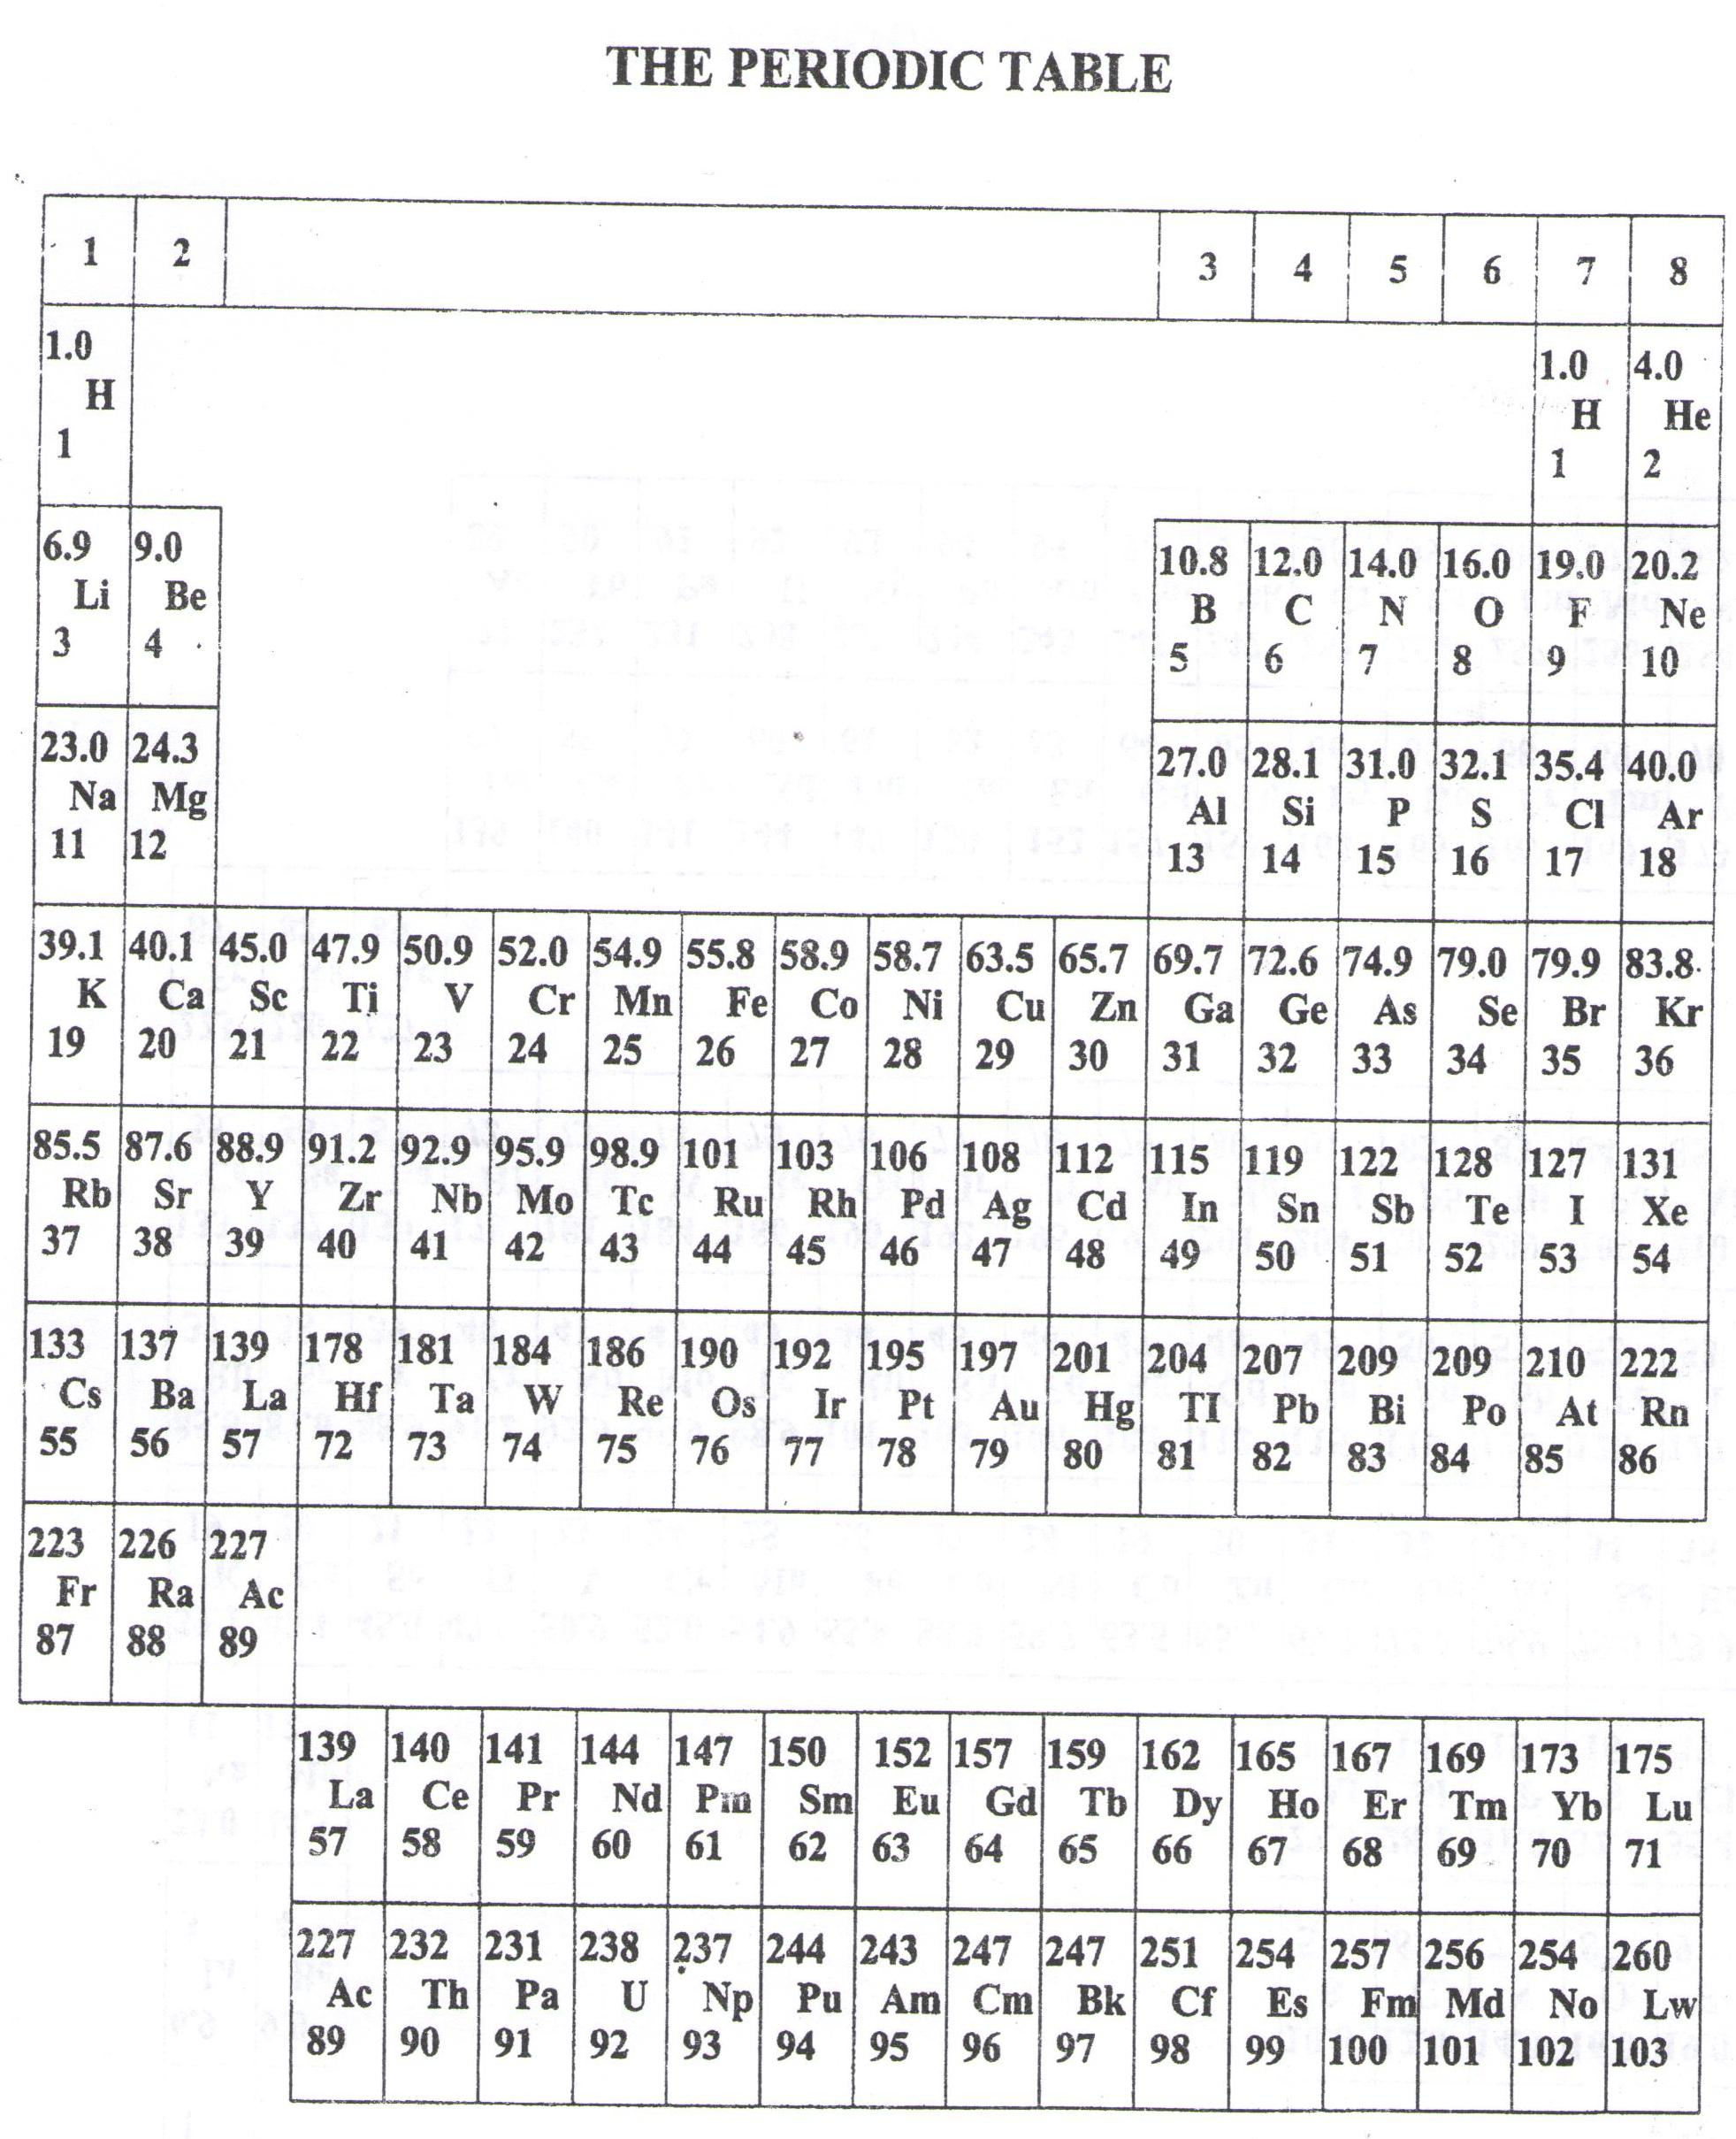

* ===END===

WELCOME TO SENIOR SIX, YEAR 2023

This is the last page of the printed paper, Page 06